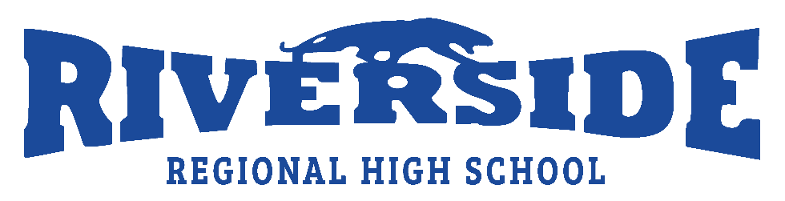
AUTHORIZATION FORM 2019-2020
Please read carefully, circle YES and initial each section before signing at the bottom and returning the form to the school.
I am aware that to maintain a safe environment for all Riverside Regional High School students, the school administration must be aware if my child regularly takes medication during school hours and/or extracurricular activities. | YES |  | _________  ^{INITIALS}
I am aware that the administration of all medication is the responsibility of my child unless prior arrangements have been made with the school administration. | YES |  | _________  ^{INITIALS}
I am aware that Riverside Regional High School has a zero-tolerance policy for any form of intimidation and/or bullying involving any member of the RRHS student body or staff. I am also aware that all situations of this nature will be dealt with on a case by case basis with the individuals involved, the behavior technician, the school administration, and the police if necessary. | YES |  | _________  ^{INITIALS}
I understand that my child may occasionally leave the school during lunch and/or recess and that student supervision is limited to Riverside Regional High School property. | YES |  | _________  ^{INITIALS}
I have read and discussed the School Expectations section of the RRHS student agenda with my child. | YES |  | _________  ^{INITIALS}
NAME OF CHILD: | LEVEL:
PARENT’S/GUARDIAN’S SIGNATURE: | DATE:

